**Week 6 Solutions**

**React**

1. **ReactJS-HOL** .

Create a new React Application with the name “myfirstreact”, Run the application to print “welcome to the first session of React” as heading of that page.

The code and the folder structure is attached in the **Week 6/1 reactjs HOL/myfirstreact**  folder

**Output :-**

**Chrome – http://localhost:3000/**

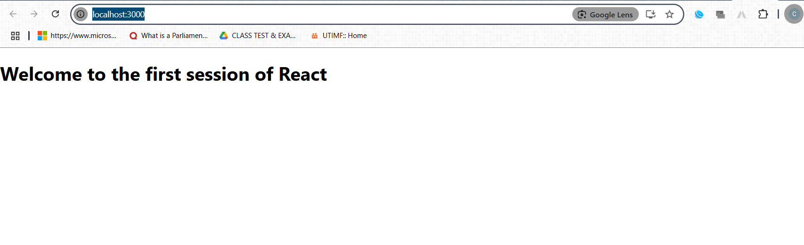

**The hands on file and folder is attached along with it**